

**Project Status Report**



**Project Name:** Faculty Loading System

**Department:** SoCIT

**Focus Area:** Sysadd1

**Product/Process:**



**Prepared By:**

|  |  |
| --- | --- |
| **Document Owner(s)** | **Project/Organization Role** |
| Rafael Ochotorena | Project Manager |
| Louise Gabrielle Lazaro | Project Manager/Researcher |
| Jameiah Nicole Jauod | Project Analyst/Researcher |
| Von Matthew Alfafara | Project Analyst/Designer |
| Allen Baldovino | Project Analyst/Designer |

**Project Status Report Version Control**

|  |  |  |  |
| --- | --- | --- | --- |
| **Version** | **Date** | **Author** | **Change Description** |
| 2.0 | 7/18/16 | Jameiah Jauod | Add other diagrams |
| 2.1 | 7/19/16 | Rafael Ochotorena | Update diagrams |
| 2.2 | 7/22/16 | Louise Lazaro | Add other diagarams & check diagrams |

**TABLE OF CONTENTS**

1 PROJECT STATUS REPORT PURPOSE 3

2 PROJECT STATUS REPORT TEMPLATE 3

2.1 Project Status Report Details 3

2.2 Project Status Report Template 3

3 PROJECT STATUS REPORT APPROVALS 3

4 APPENDICES 3

4.1 Document Guidelines 3

4.2 Project Status Report Sections Omitted 3

# PROJECT STATUS REPORT PURPOSE

The Project Status Report is a document that Project Managers may use as a means of formal regular reporting on the status of a project to key project stakeholders, including the Steering Committee, Project Sponsor, and Senior Manager.



# PROJECT STATUS REPORT TEMPLATE

## Project Status Report Details

[The team is currently focusing on researching to related projects. Due to alternate schedules between the members, conflict to time has been common lately and meetings were less likely happening. The team is now managing a schedule in order for us to present the report and revisions on schedule.]

* [Ongoing Project]

* + [The Faculty Loading System is a system where algorithm and analytics will be used in order for the schedule of professors be utilized and loaded systematically.]

* + [On the Milestone Deliverables, we are focusing to add other required diagrams and update our ERD, context diagram, and data flow diagrams.]

* + [We are currently behind schedule due to the alternate schedules the team members have.]

* [Budget Report— N/A]

* [Risk Management Report—No specific changers so far but focusing on finishing reports and revisions on schedule]

* [Issues Report—Time management has become a major problem especially now that the team have uneven schedules. We can only hold meetings every Wednesday and Saturday. We may be planning on finalizing a specific schedule of meetings in order to finish reports and revisions as soon as possible.]

* [The team should focus on revising the ERD for the next report an finalizing the schedule of meetings of the team and with the adviser.]

## Project Status Report Template

|  |  |  |
| --- | --- | --- |
| Project Name | | |
| Prepared By:  Louise Gabrielle Lazaro | Date:  7/18/16 | Reporting Period:  7/18/16 to 7/22/16 |
| Project Overall Status:  [The project manager assigned each member to do a specific diagram.] | | |
| Project Summary:  [Researchers are updating and adding other necessary diagrams.] | | |
| **Milestone Deliverables performance reporting over last period**   |  |  |  |  | | --- | --- | --- | --- | | **Milestone Deliverables** | **Due Date** | **% Completed** | **Deliverable Status** | | Milestone 1 | | | | | * Update event table | 7/20/16 | 50% | On Schedule | | * Update ERD | 7/21/16 | 30% | On Schedule | | * Update Context Diagram | 7/21/16 | 40% | On Schedule | | Milestone 2 | | | | | * Update project context | 7/22/16 | 30% | On Schedule | |  |  |  |  | |  |  |  |  | | | |
| **Milestone Deliverables scheduled for completion over next period**   |  |  |  |  | | --- | --- | --- | --- | | **Milestone Deliverables** | **Due Date** | **% Completed** | **Deliverable Status** | | Milestone 1 | | | | | * Update Scope and Limitation | 7/26/16 | 20% | Ahead of Schedule | | * Update Event Table | 7/26/16 | 20% | Ahead of Schedule | | * Revise papers | 7/26/16 | 10% | Ahead of Schedule | | Milestone 2 | | | | |  |  |  |  | |  |  |  |  | |  |  |  |  | | | |
| **Project impact of milestone success or failure for project remainder**   |  |  | | --- | --- | | According to the milestone deliverable status,  we are able to finished one portion of the  documentation each day and still on the  process of working with the other parts  based on its respective schedules. | We weren’t able to settled the schedules  earlier before the meeting comes due to altered  class schedules of each member. Since we are considering the available schedules of each member, chances are given that it will be most likely delay on producing the outputs. | | | |
| **Project** **Budget/Financial Status**   |  |  |  |  | | --- | --- | --- | --- | | **Budget Item** | **Planned Budget** | **Actual Cost** | **Variance/Explanation** | | N/A | N/A | N/A | N/A | | N/A | N/A | N/A | N/A | | | |
| **Project Risk Management Status**   |  |  |  |  |  | | --- | --- | --- | --- | --- | | **Risk and Description** | **Risk Chance** | **Risk Impact** | **Risk Priority** | **Change from Last Review** | | Revisions | Medium | High | High | Changes background of the problem and statement of the problem | |  |  |  |  |  | | | |
| **Project Issue Management Status**   |  |  |  |  |  | | --- | --- | --- | --- | --- | | **Issue and Description** | **Project Impact** | **Target Due Date** | **Issue Status** | **Issue Resolution** | | Revisions | Medium | 7/29/16 | Open | Changes made this week were made | |  |  |  |  |  | | | |
| **Project Recommendations**   |  | | --- | | * Will the project be completed on time and on budget?   According to the statuses and completion of the above milestone deliverables, the project will not likely be completed on time due to the team’s uneven schedules. If the schedules of each member are adjusted accordingly, the results would be otherwise. Budget is not concerned until further notice.   * Will the project deliverables be completed within acceptable quality levels?   It will not be guaranteed that the project deliverables will have acceptable quality levels upon completion due to lack of skills in teamwork. | | | |
| **Objectives for Next Project Status Review**   |  | | --- | | * To update all the proposed diagrams * To add more diagrams * To conduct a research on different related projects | | | |
| **Related Project Information**   |  | | --- | | * Budget Report Summary – N/A  * Issue Record Report – N/A  * Scope Change Report – N/A  * Project Work Plan  * Project Metrics/Statistics  * Quality Management Review.] | | | |



# PROJECT STATUS REPORT APPROVALS

**Prepared by** Louise Gabrielle Lazaro

Project Manager/Researcher

**Approved by** Ms. Rhea Valbuena

Project Advisor/Executive Director

__________________________________

Client Sponsor

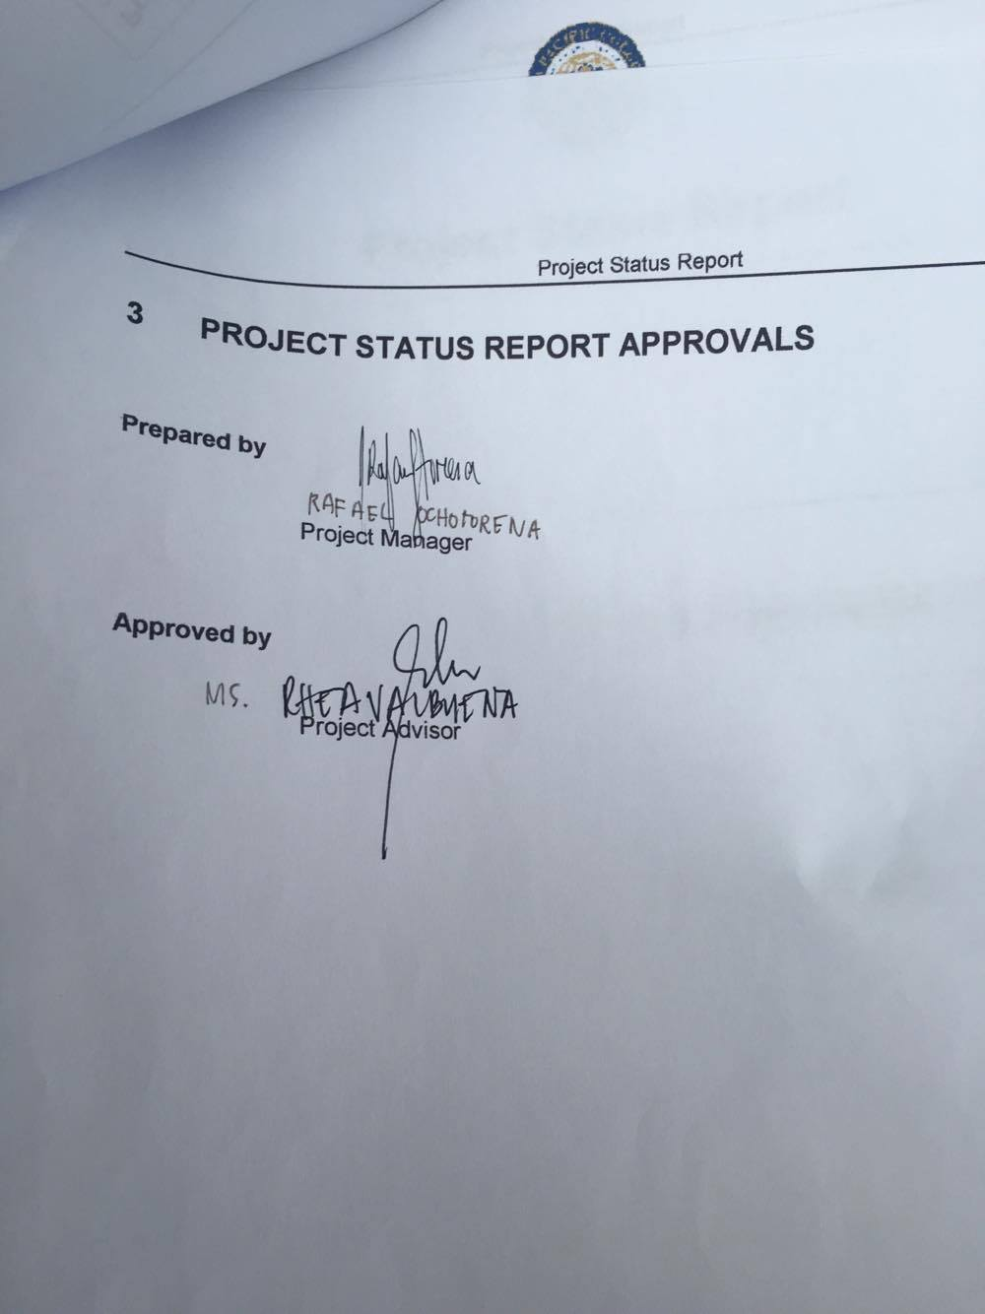



# APPENDICES

## Document Guidelines

## Project Status Report Sections Omitted

